**Data Visualization using PowerBI Desktop**

“Largest cities.csv file data pre-processing done in python ipynb file (jupyter notebook file)”.

After above preprocessing, follow steps below:

1.

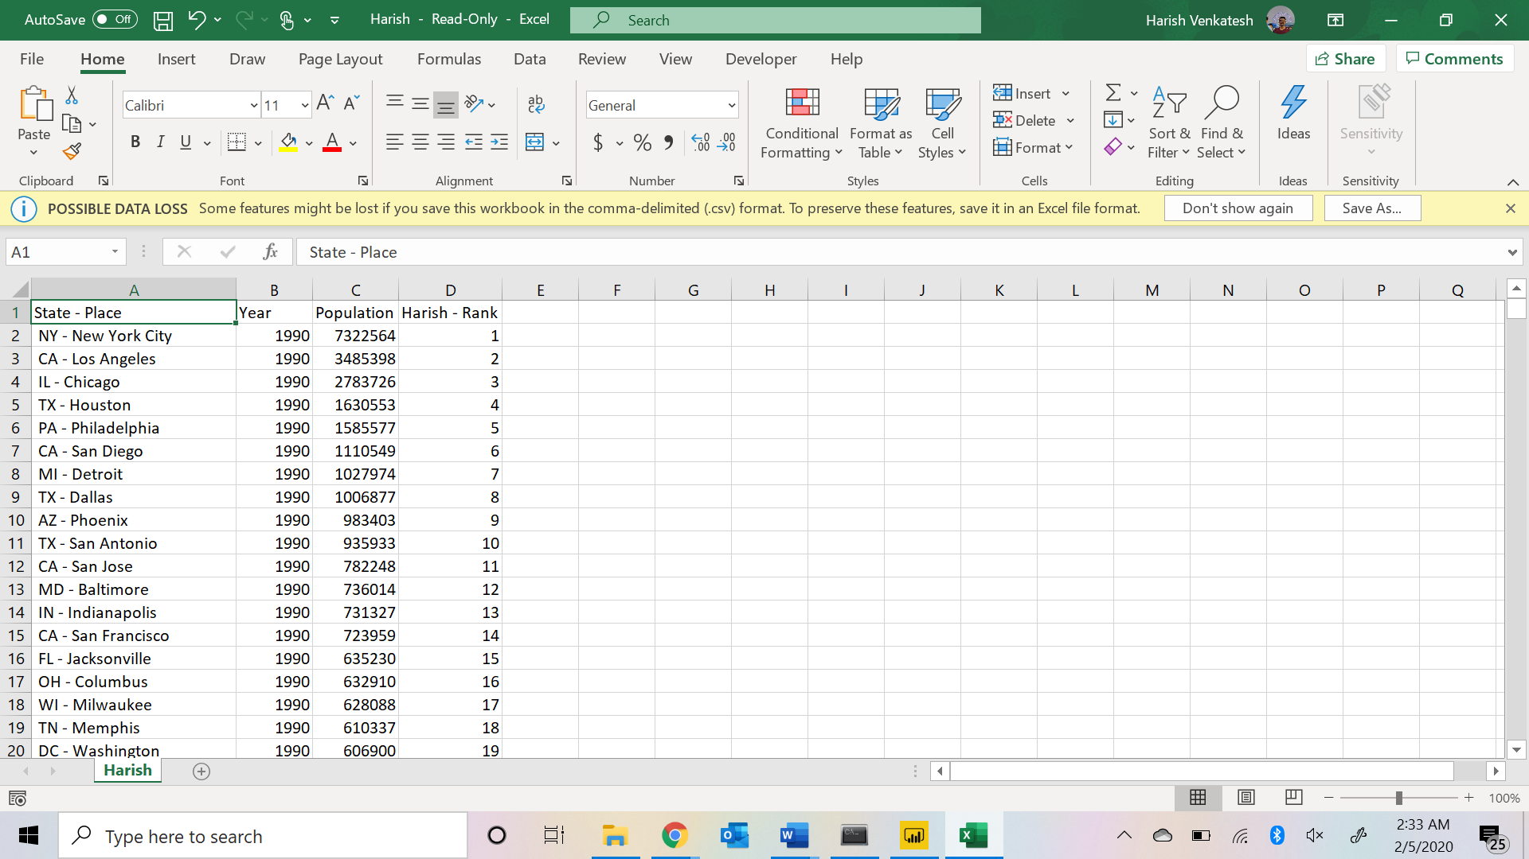

2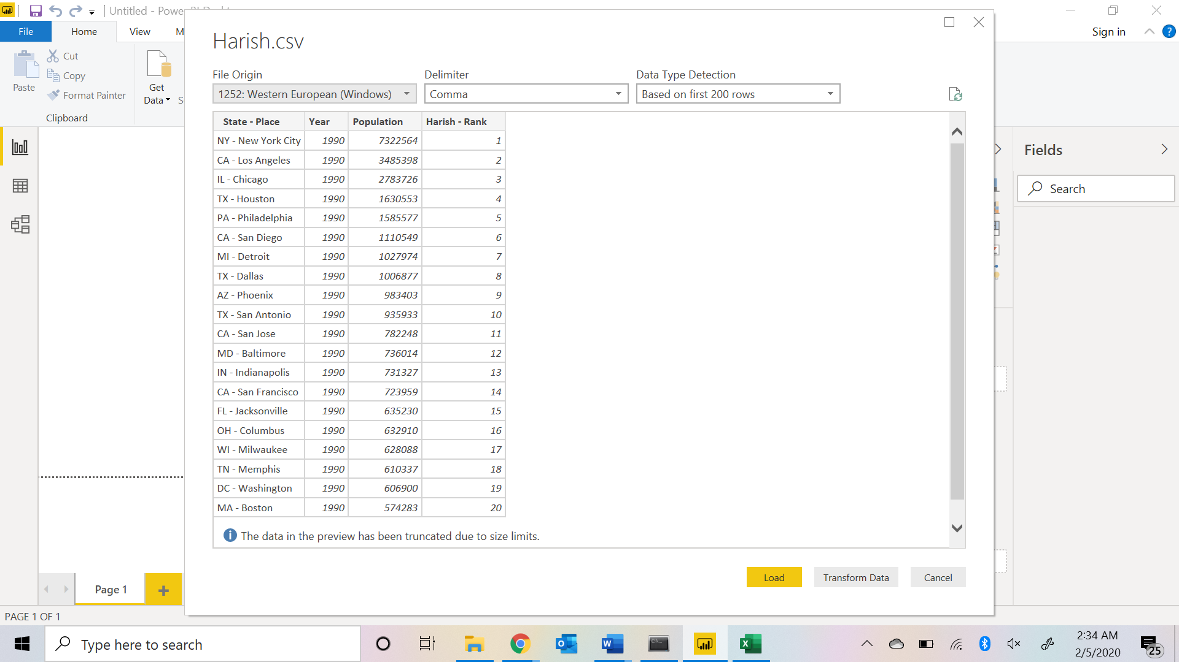

3 Creating slicer (filter) of Rank

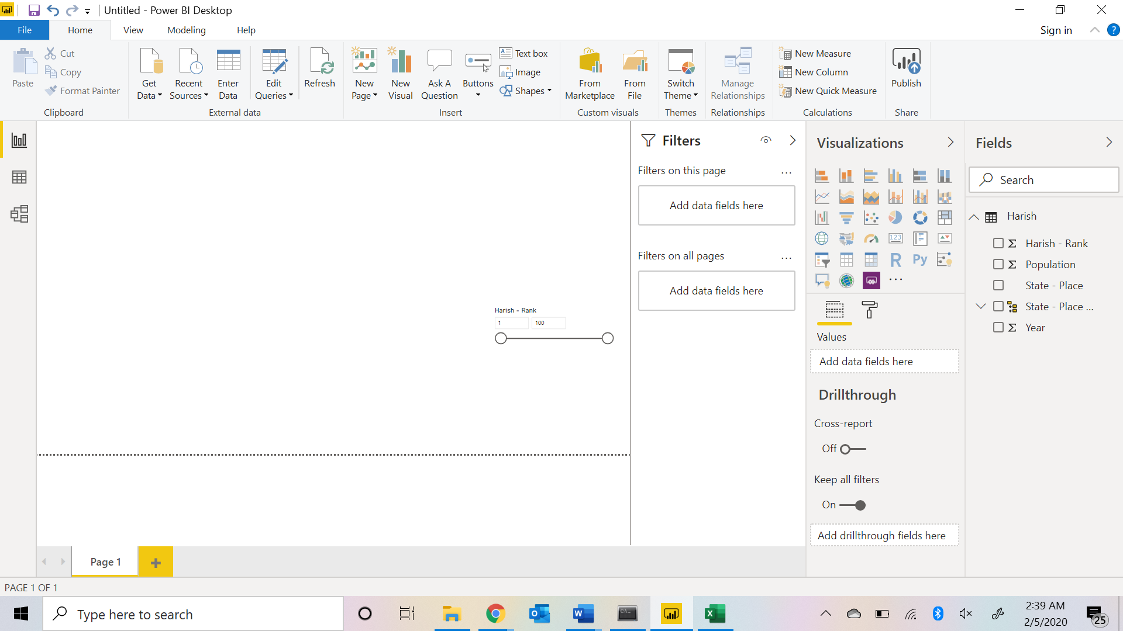

4 ADD new workforce calculation : workforce = (SUM(student[Population]))*.60

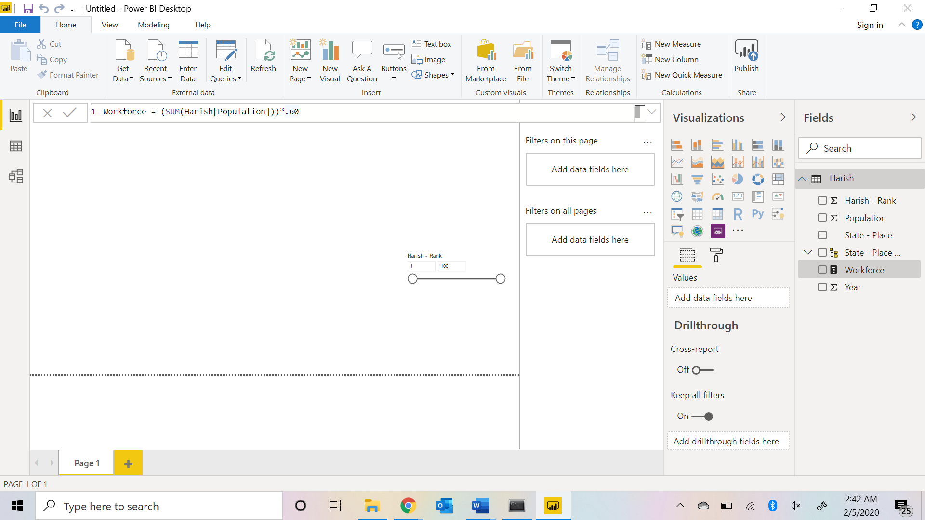

5

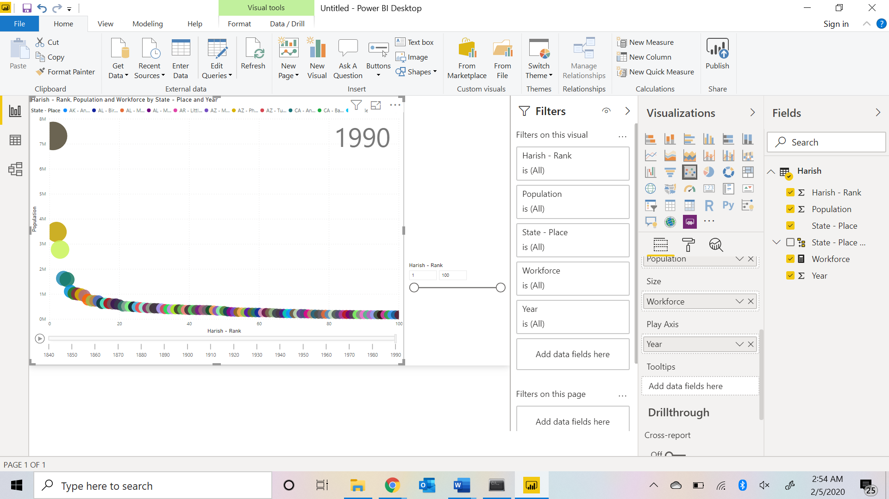

6

